1. **Gajula, Vineeth**
2. Team D – Phoenix
3. Client: Dr. Michael Oudshoorn (oudshoorn@nwmissouri.edu)
4. Project: Slack/Hipchat collaboration tool
5. Team Role: Communications and documentation management
6. Iteration plan:

I have been assigned the role of Communications and documentation management for this project. I am responsible for tracking the changes in documentation and manage the communications for the project. I think 15% of work is completed by writing test cases for shared calendar requirement, Cost/Time Distribution, and Drawing Gantt charts. I think that the requirements in which am involved are a reasonably on schedule for this week.

**Accomplishments made last week:**

I have written test cases for the use case diagram for the shared calendar. We have updated the requirements document and now shared calendar falls under requirement 2. So, I have finished writing different test cases for requirement R 2.1 to R 2.5 each having a short description, test case scenario and an expected output in a tabular format. I also completed writing Cost/Time Distribution document which covers the budget estimation in terms of hours for this project. I have also designed a Gantt chart for showing the amount of work done and planned work to be done for GDP 1. I have documented the effort distribution as part of individual submission. I spent around 40 hours outside class towards the project.

**Tasks to complete this week:**

* Meet with the team and discuss on functional specifications.
* Update the current problem statement.
* Push all the midterm project materials to the GitHub repository.
* Manage the documentation for this week’s group report and make sure it gets pushed to the GitHub repository.
* I will dedicate around 40 hours this week outside the class to contribute towards the progress of the project.

1. **a copy of a complete post from one week ago**
2. **Gajula, Vineeth**
3. Team D – Phoenix
4. Client: Dr. Michael Oudshoorn (oudshoorn@nwmissouri.edu)
5. Project: Slack/Hipchat collaboration tool
6. Team Role: Communications and documentation management
7. Iteration plan:

I have been assigned the role of Communications and documentation management for this project. I am responsible for tracking the changes in documentation and manage the communications for the project. I think 10% of work is completed by designing use cases and writing project management plan. I think that the requirements in which am involved are a bit behind the schedule for this week. To get back on track I think I should document the test case for the shared calendar which am working on.

**Accomplishments made last week:**

I have designed use case diagram for the shared calendar which comes under requirement 1 for the project. The use case diagram tells about the various functionality a user can perform while interacting with the system like creating, editing, deleting an event, or sending invitations for the event etc. For now, I have designed it based on what I worked on writing the project management plan describing what the project overview is, what are the project deliverables, what type of organizational structure is implemented, few project responsibilities, budget allocation and project schedule. Had a meeting with client and talked about the functional requirements for the project. Below are the notes taken from client discussion.

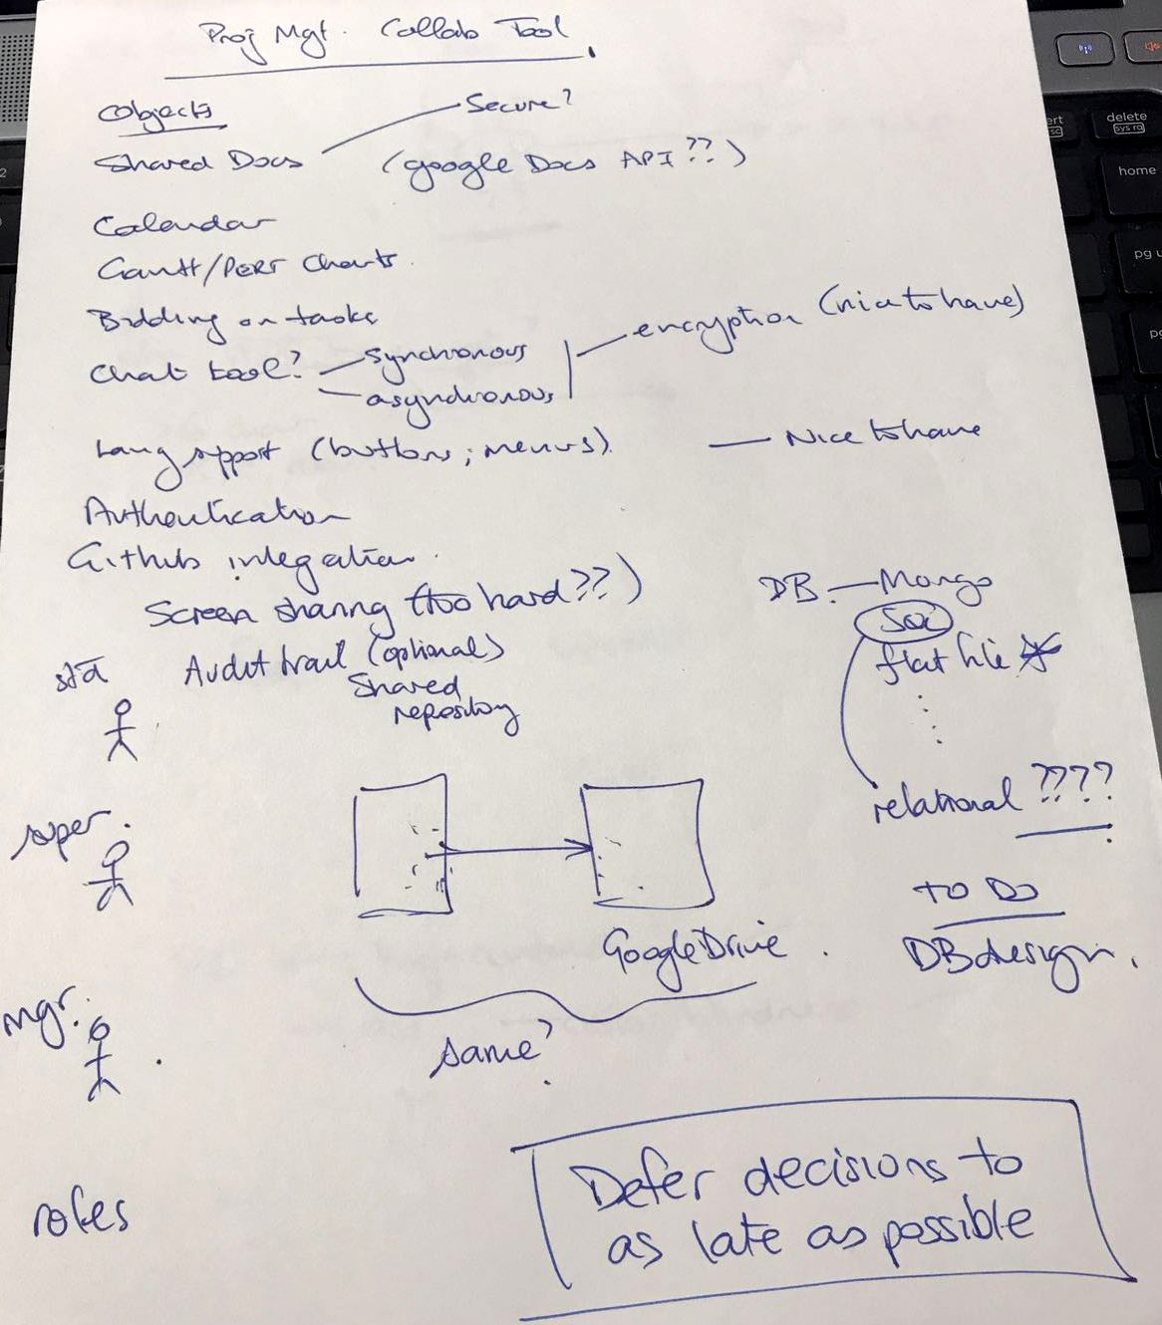

Fig 1. Client Notes

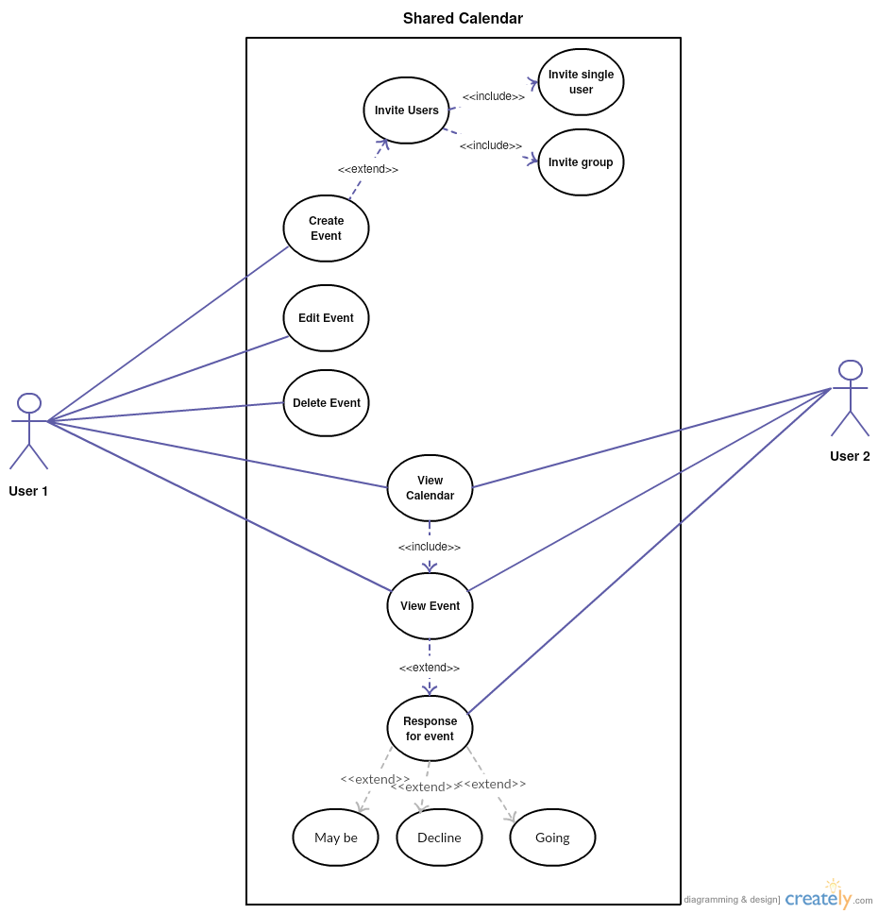

Fig 2. Use case diagram

I spent around 39 hours outside class towards the project.

**Tasks to complete this week:**

* Finish the requirement 1 (**R1**) which is in the functional requirements section.
* Draw Gantt Charts for the project which shows the amount of work distributed and work done.
* Write the Effort distribution for the project.
* Write the cost estimation and time estimation efforts for the project.
* Manage the documentation for this week’s group report and make sure it gets pushed to the GitHub repository.
* I will dedicate 39 hours this week outside the class to contribute towards the progress of the project.